**IBM NALAYA THIRAN**

**DEVLOP A WEB APP USING NODE RED**

|  |  |
| --- | --- |
| **Team ID** | **PNT2022TMID44924** |
| **Project Name** | **Project – IOT ENABLED SMART FARMING APPLICATION** |

**TEAM LEAD : ABARJITHA R**

**TEAM MEMBER 1: GAYATHRI C**

**TEAM MEMBER 2: HEMA MALINI S**

**TEAM MEMBER 3: SARITHA P**

TEAM MEMBER4: KABILAN S

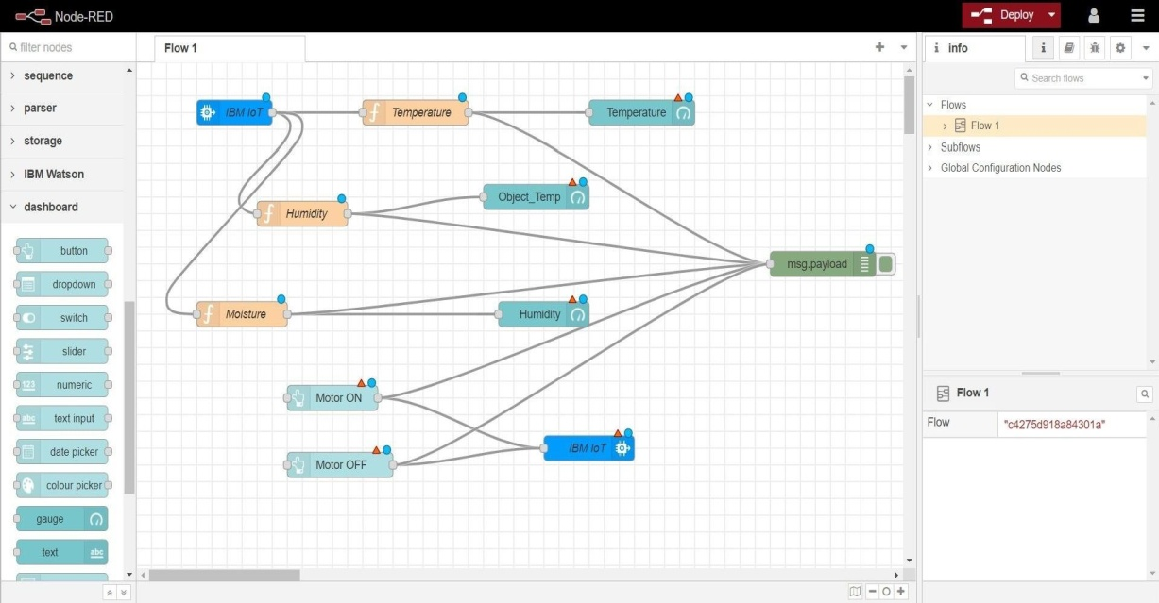STEP 1:-

STEP 2:-

**\*\*\*\*\*\*\*\*\*\*\*\*\*\*\*\*\*\*\*\*\*\*\*\*\*\*\*\*\*\*\*\*\*\*\*\*\*\*\*\*\*\*\*\*\*\*\*\*\*\*\*\*\*\*\*\*\*\*\*\*\*\*\***